# Assignment 1:

MySQL

# Develop:

Developing a social web app for amateur authors and creative writers, allowing them to share their creative work/writings, gather feedback, and communicate with other authors/writers.

1. Consider below features and design the normalized database schema using phpMyAdmin or MySQL Workbench:
   1. Users can register for the site. User registration process captures information like:
      1. First Name
      2. Last Name
      3. Username
      4. Password
      5. Location Details
   2. Create and modify profile details and account settings
   3. User can suspend his account for certain days
   4. User can link his/her external accounts post-registration:
      1. Twitter
      2. Facebook
   5. Users can create new post, tag the post and categorize their posts
   6. Read, comment on and "favorite" other users' posts
   7. Users can decide whether they want to receive notifications or not for the users they are following.
   8. "Follow" other users to get notifications of their activity
      1. Notification of Followers
      2. Notification of Comments
   9. Search and browse content and get suggested posts/users
2. The assignment solution must include the brief description of each table and how it is linked with other tables (using foreign key)

# Technologies Used:

1. MySQL
2. MySQL Workbench OR
3. phpMyAdmin

# Assignment 2:

MySQL

# Scenario:

Given is the database design of the Friends Relationship.

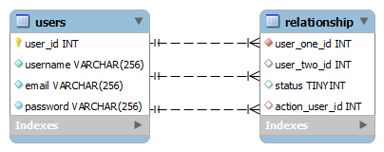

## Users Table

This table contains 4 fields with user_id as the PRIMARY KEY, with AUTO_INCREMENT set to it.

## Relationship Table

The first two fields correspond to the id of the two users who is to be related and status represents the relationship status between the two users.

1. Status Codes

|  |  |
| --- | --- |
| Code | Meaning |
| 0 | Pending |
| 1 | Accepted |
| 2 | Declined |
| 3 | Blocked |

1. Action User: action_user_id represent the id of the user who has performed the most recent status field update.
   1. If user with id 1 has sent a request to user with id 2, action user id will be 1. So, the user who sent the friend request will be user 1.
   2. If user id 2 has blocked user id 3, then user id 2 will be the action user id. The user id 2 has blocked user id 3.
2. Following is a sample dump of the inserted user relationship data:
   1. 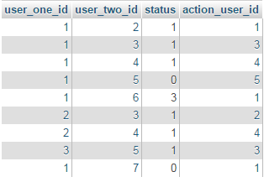

# Questions:

1. What should be done to make users pair insertion unique i.e. to avoid duplicate user relationship creation?
2. What will be the insert query to insert a new Friend request sent by user 1 to user 2?
3. What will be the query to update the status of the friend request i.e. accepting friend request sent to user 2 by user 1?
4. What will be the query to check if any two users are friends?
5. What will be the query to retrieve all the users’ friends? Here user 1 is the logged in user.
6. What will be query to get the entire pending user request for the user from other users? Here user 1 is logged in.
7. What will be the query to retrieve the friend request status when the logged in user visits the profile of another user? Here, user 1 is the logged in user. User 1 visits the profile of user7.